**SPH3U 7.4 Nuclear Fission**

1. **Mass-energy equivalence**

|  |  |
| --- | --- |
| Mass-energy equation: |  |
| c |  |
| Law of conservation of mass-energy: |  |

|  |  |  |  |  |
| --- | --- | --- | --- | --- |
| **Particle** | **Mass (kg)** | | **Mass (u)** | |
| proton | 1.672 6014 x 10-27 | | 1.007 276 | |
| neutron | 1.674 920 x 10-27 | | 1.008 665 | |
| electron | 9.109 56 x 10-31 | | 0.000 549 | |
| Atomic mass unit (u): | |  | |
| Mega-electron volt: | |  | |

|  |  |
| --- | --- |
| Mass defect: |  |
| Binding energy: |  |

Determine the mass defect and binding energy of a lithium-7 nucleus, given that its actual atomic mass is 7.016 00 u, and using the particle mass table above.

1. **Nuclear fuel**

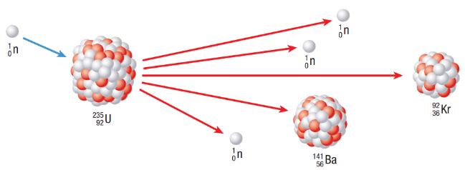

|  |  |
| --- | --- |
| U-235 fission: | $${}_{92}^{235}{\text{U}}+{}_{0}^{1}{\text{n}}→{}_{36}^{92}{\text{Kr}}+{}_{56}^{141}{\text{Ba}}+3\left({}_{0}^{1}{\text{n}}\right)$$ |
| Chain reaction: |  |

|  |  |
| --- | --- |
| Other nuclear fuels: |  |

What is the energy yield of the following fission reaction? Use the given masses below.

$${}_{92}^{235}{\text{U}}+{}_{0}^{1}{\text{n}}→{}_{55}^{140}{\text{Cs}}+{}_{37}^{93}{\text{Rb}}+3\left({}_{0}^{1}{\text{n}}\right)$$

mass of U (mU) = 235.044 u

mass of Cs (mCs) = 139.909 u

mass of Rb (mRb) = 92.922 u

mass of neutron (mn) = 1.009 u

1. 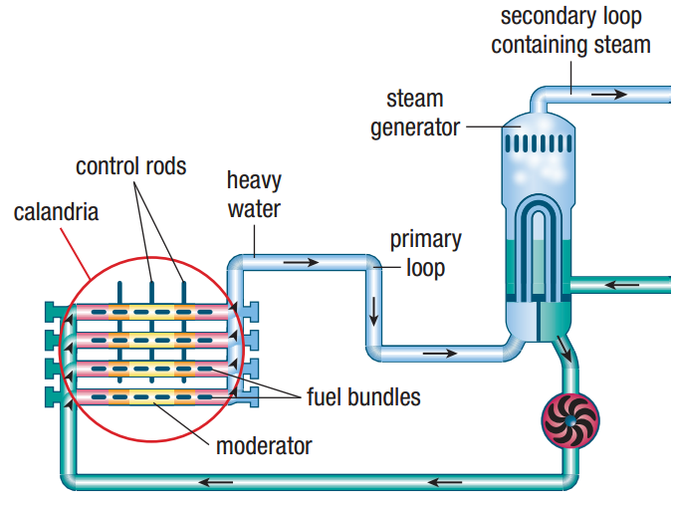**CANDU Reactors**

|  |  |
| --- | --- |
| Neutron moderation: |  |
| Natural uranium: |  |
| Radiation badges: |  |
| Waste disposal: |  |

**Homework:** page 341: #1-4